

**SHAID SMARAK COLLEGE**

Kirtipur, Kathmandu

*Assignment No. 3 of C programming*

**Submitted by :-**

2nd semester

Amir Maharjan

**Submitted to :-**

Himal Raj Gental

**Q.1 Write a program to illustrate else if ladder program to calculate grades**.

Program.

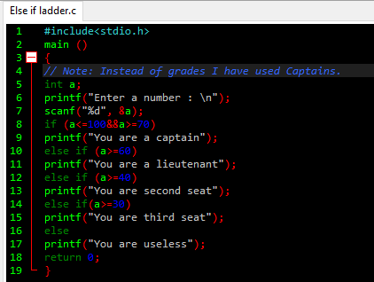

Output.

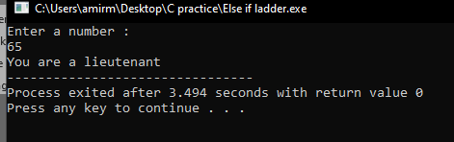

**Q.2 Write a program to illustrate switch statement: calculator program.**

Program.

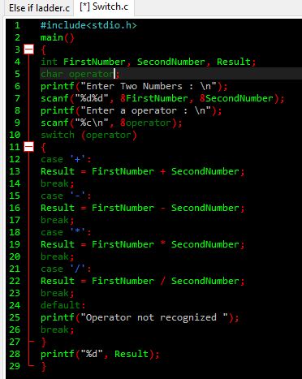

Output.

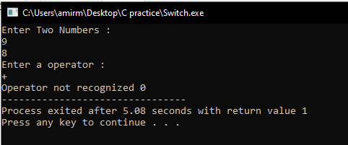

Q.3 Write a program to illustrate go-to statement: calculation sum of natural numbers.

Program.

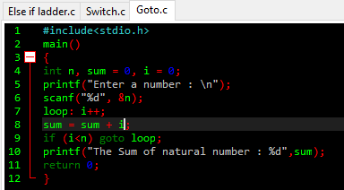

Output.

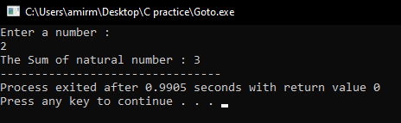

The End